**MongoDB – Complex Queries (Mujahid Hussain Khan)**

**Mongo DB Exercises - With the Restaurants Data Set**

1. Download the restaurants.zip file

2. Unzip the file, you will see restaurants.json file

3. Run the mongod server

4. Run the following command to import the json file provided. It will load the json file into the mongodb with database name - restaurants, collections name -

**mongoimport --db restaurants --collection --file restaurants.json**

5. Run mongo shell command

6. show databases

7. use restaurants

8. db..find() should print entire json data

9. Then start working on the following exercises and submit your queries as the answers to the questions

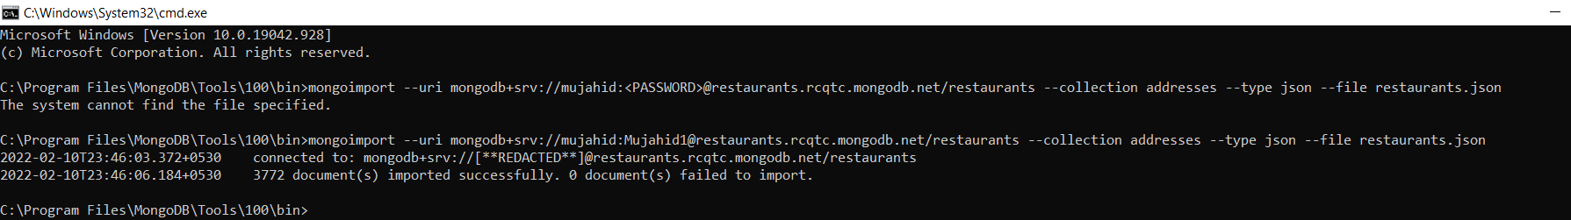

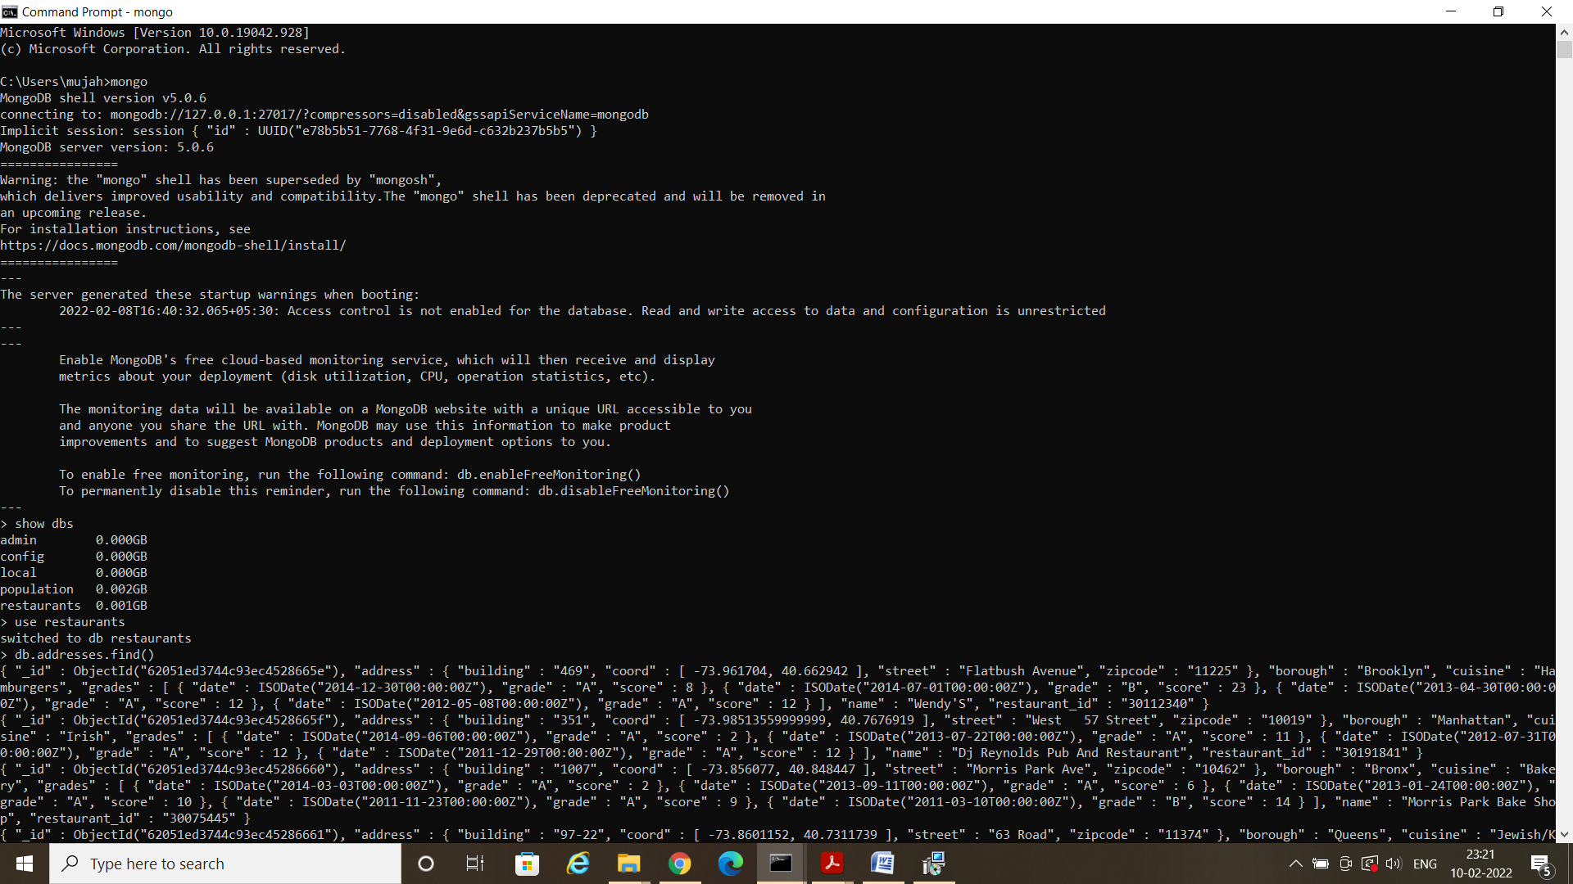

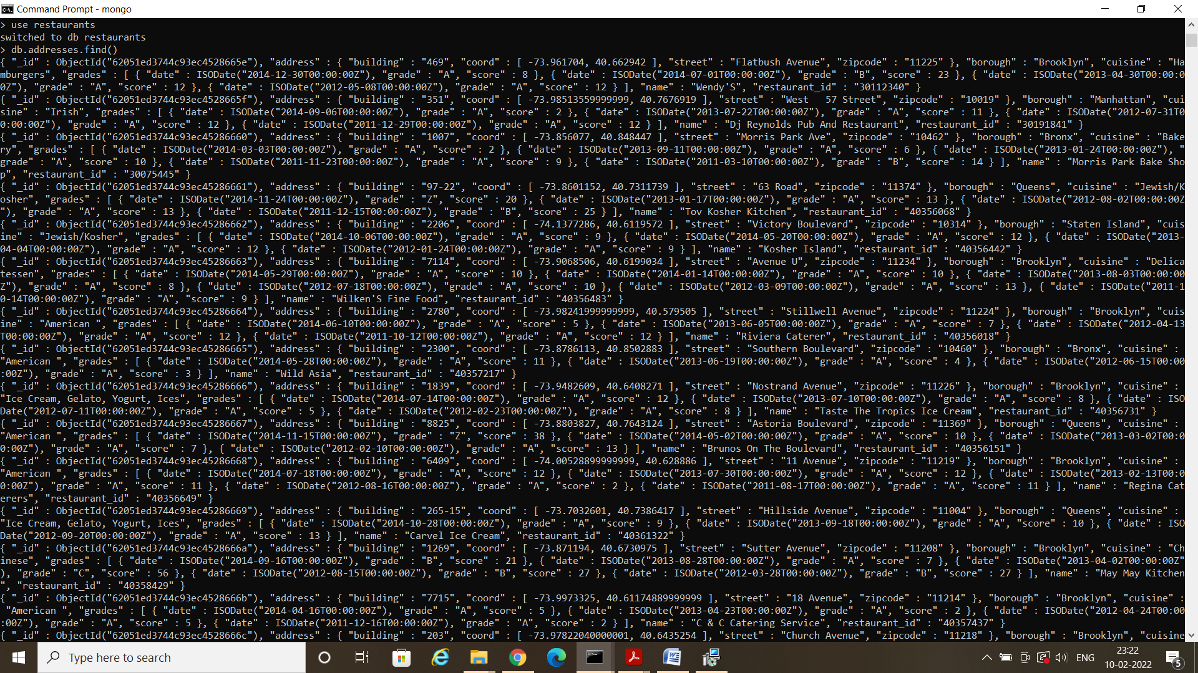

**Exercise Questions**

1. Write a MongoDB query to display all the documents in the collection addresses.

2. Write a MongoDB query to display the fields restaurant_id, name, borough and cuisine for all the documents in the collection restaurant.

3. Write a MongoDB query to display the fields restaurant_id, name, borough and cuisine, but exclude the field _id for all the documents in the collection restaurant.

4. Write a MongoDB query to display the fields restaurant_id, name, borough and zip code, but exclude the field _id for all the documents in the collection restaurant.

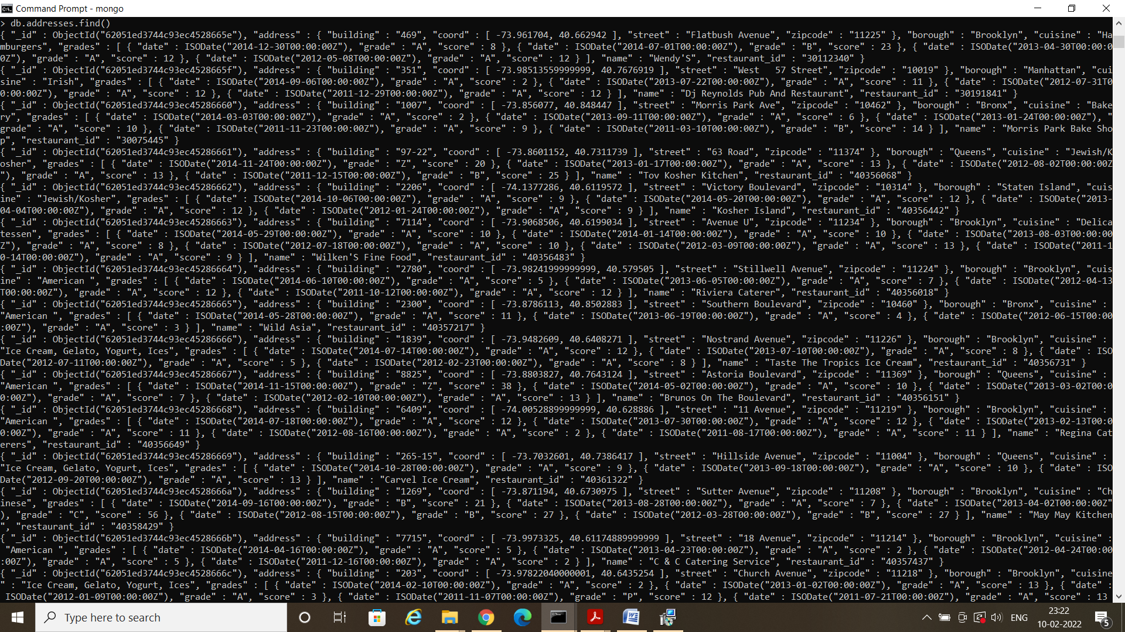

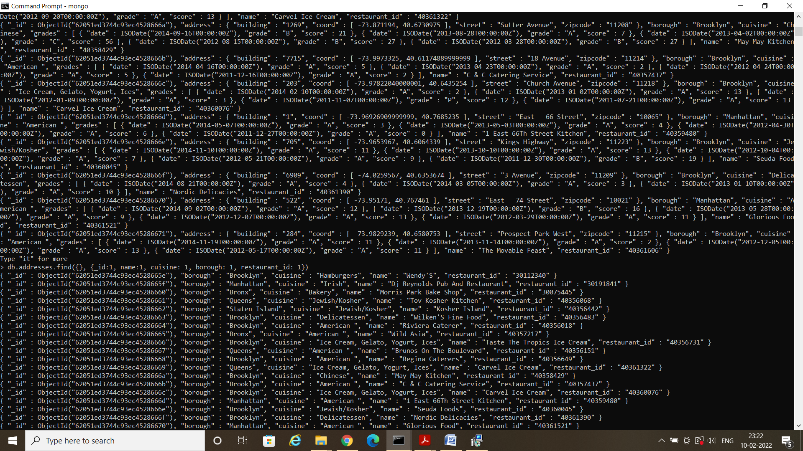

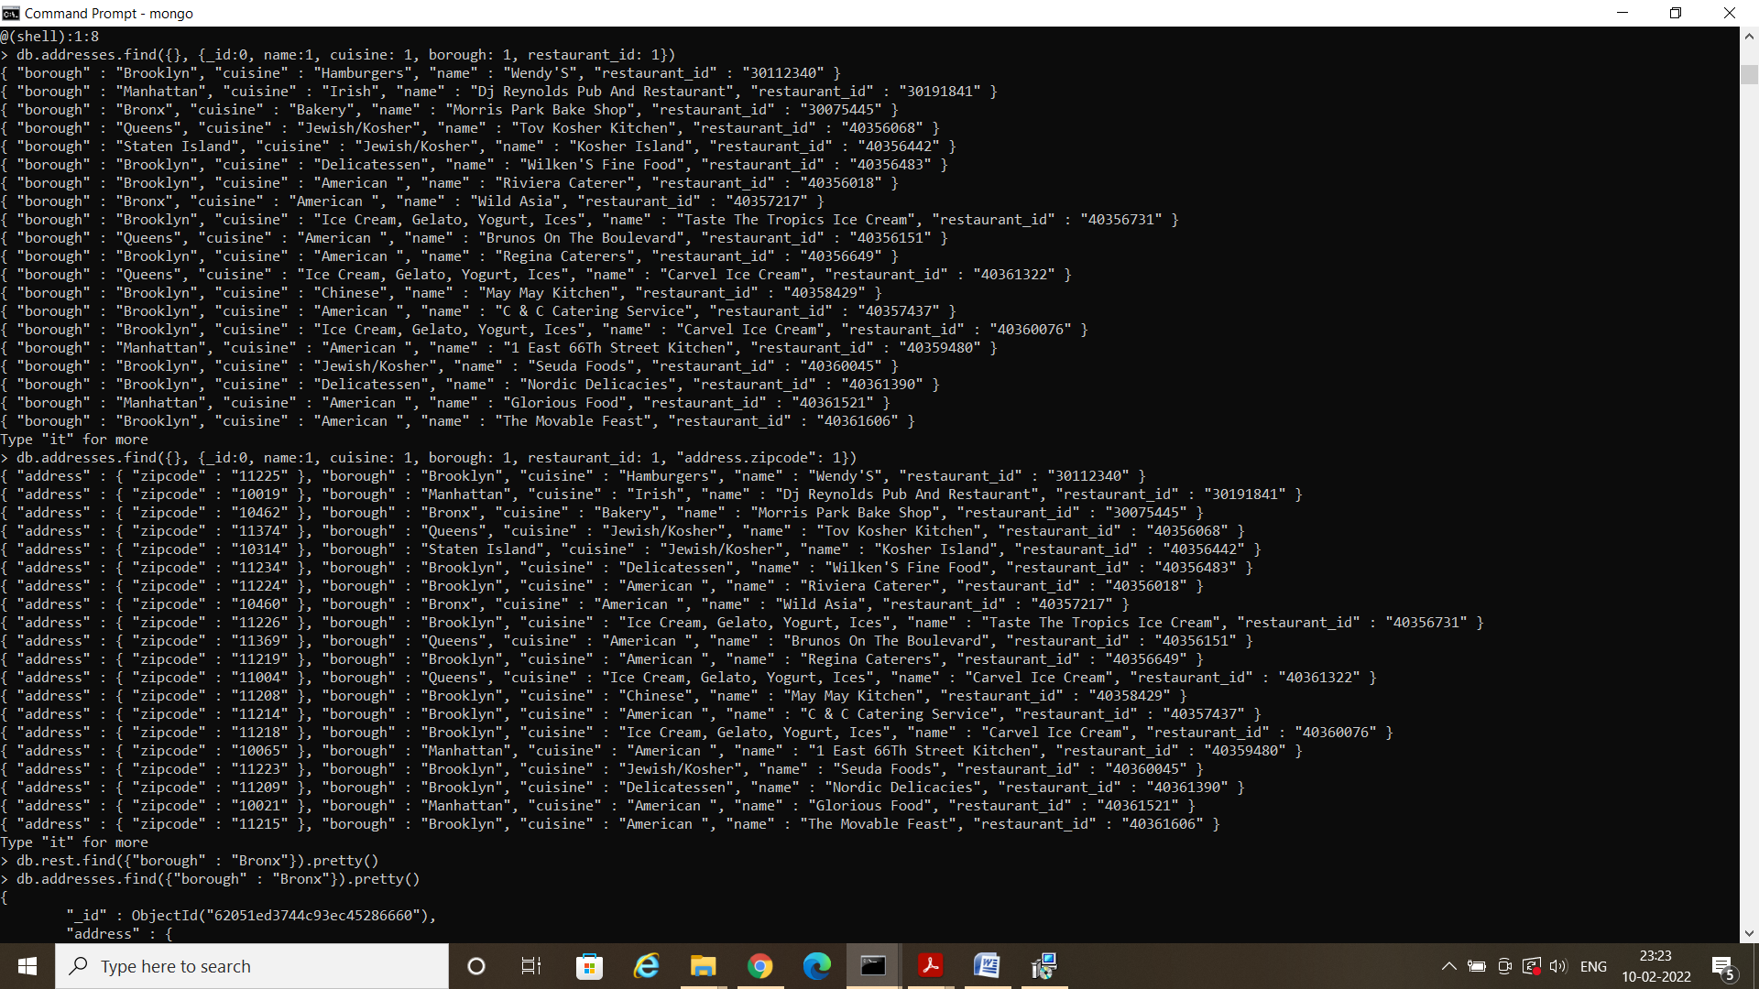

5. Write a MongoDB query to display the first 5 restaurant which is in the borough Bronx.

6. Write a MongoDB query to display all the restaurant which is in the borough Bronx.

7. Write a MongoDB query to display the next 5 addresses after skipping first 5 which are in the borough Bronx.

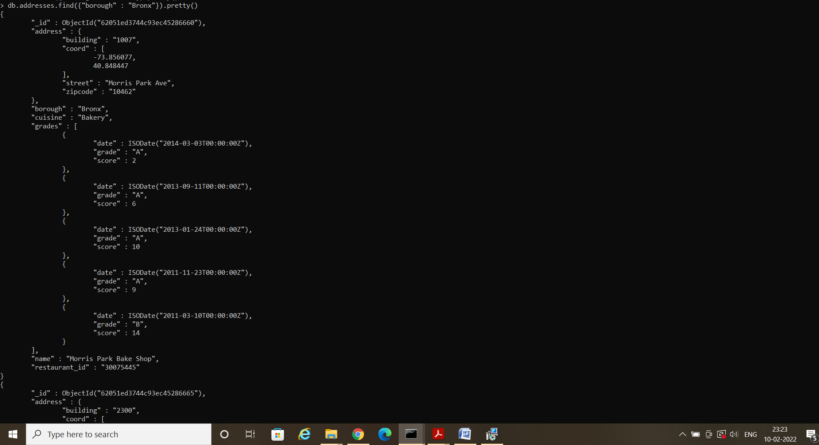

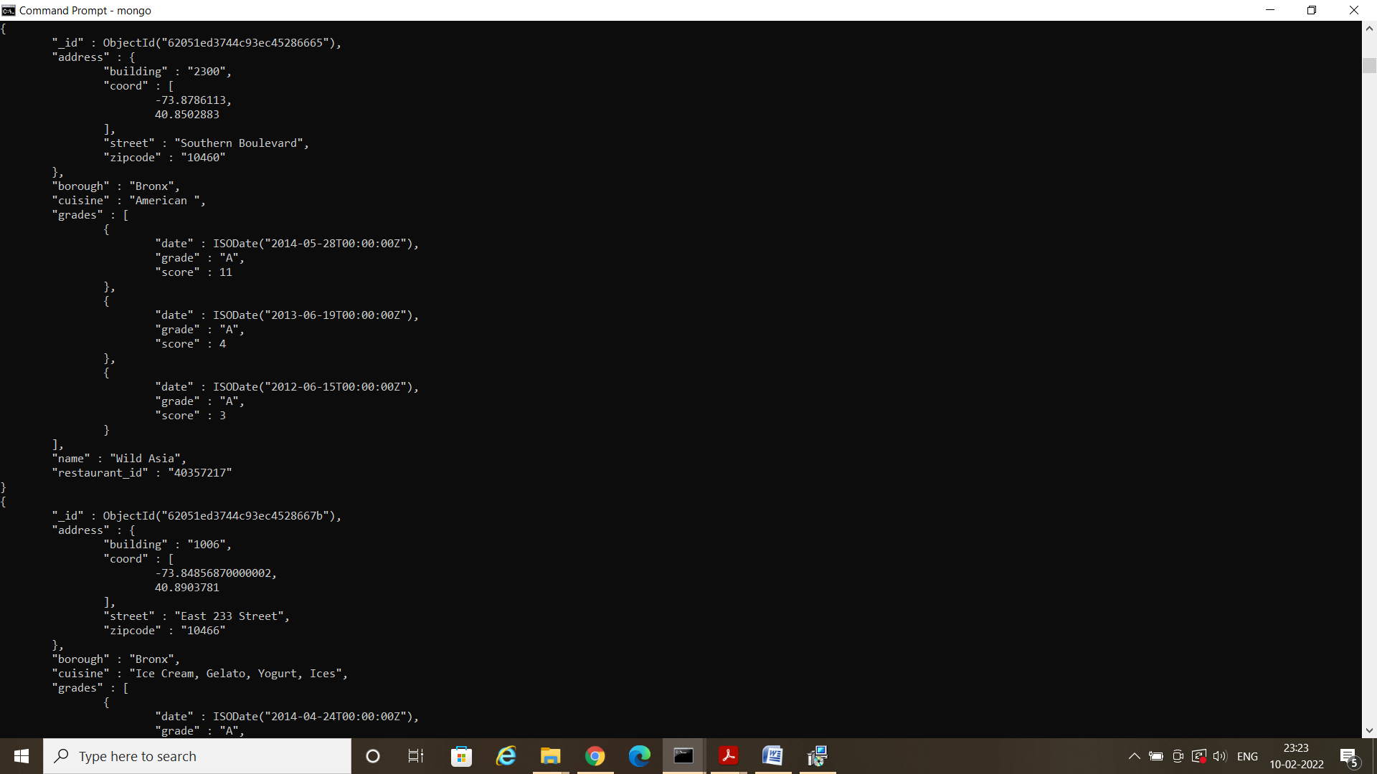

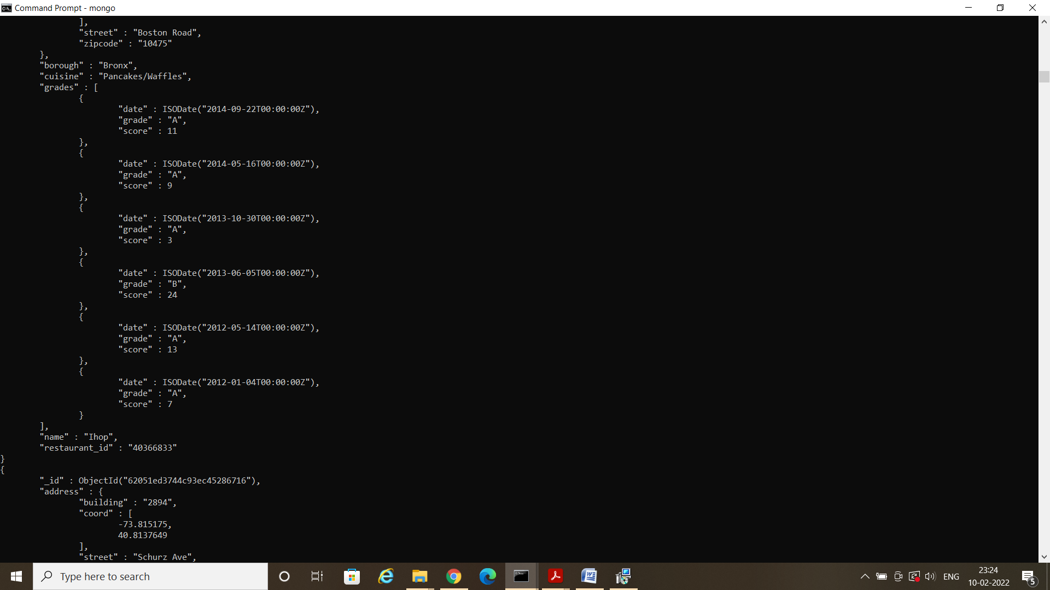

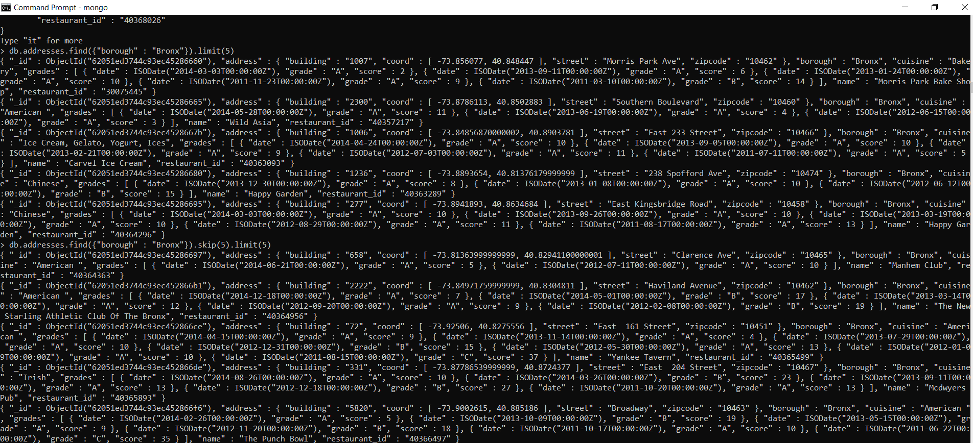

8. Write a MongoDB query to find the addresses who achieved a score more than 90.

9. Write a MongoDB query to find the addresses that achieved a score, more than 80 but less than 100.

10. Write a MongoDB query to find the addresses which locate in latitude value less than -95.754168.

11. Write a MongoDB query to find the addresses that do not prepare any cuisine of 'American' and their grade score more than 70 and latitude less than -65.754168.

12. Write a MongoDB query to find the addresses which do not prepare any cuisine of 'American' and achieved a score more than 70 and located in the longitude less than -65.754168.

13. Write a MongoDB query to find the addresses which do not prepare any cuisine of 'American ' and achieved a grade point 'A' not belongs to the borough Brooklyn. The document must be displayed according to the cuisine in descending order.

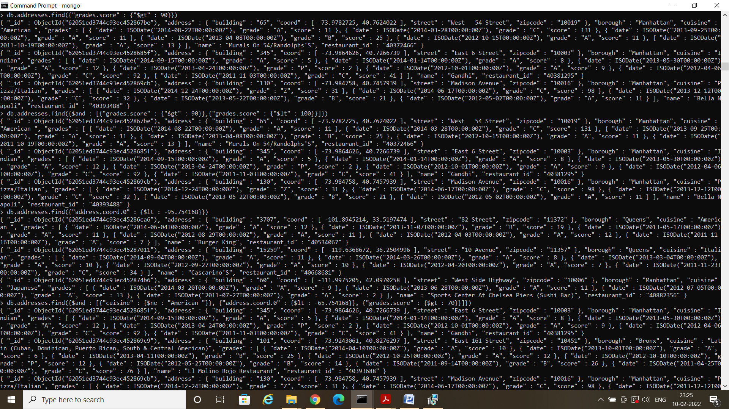

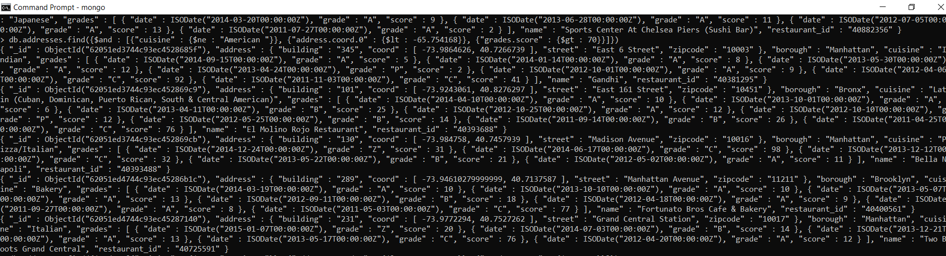

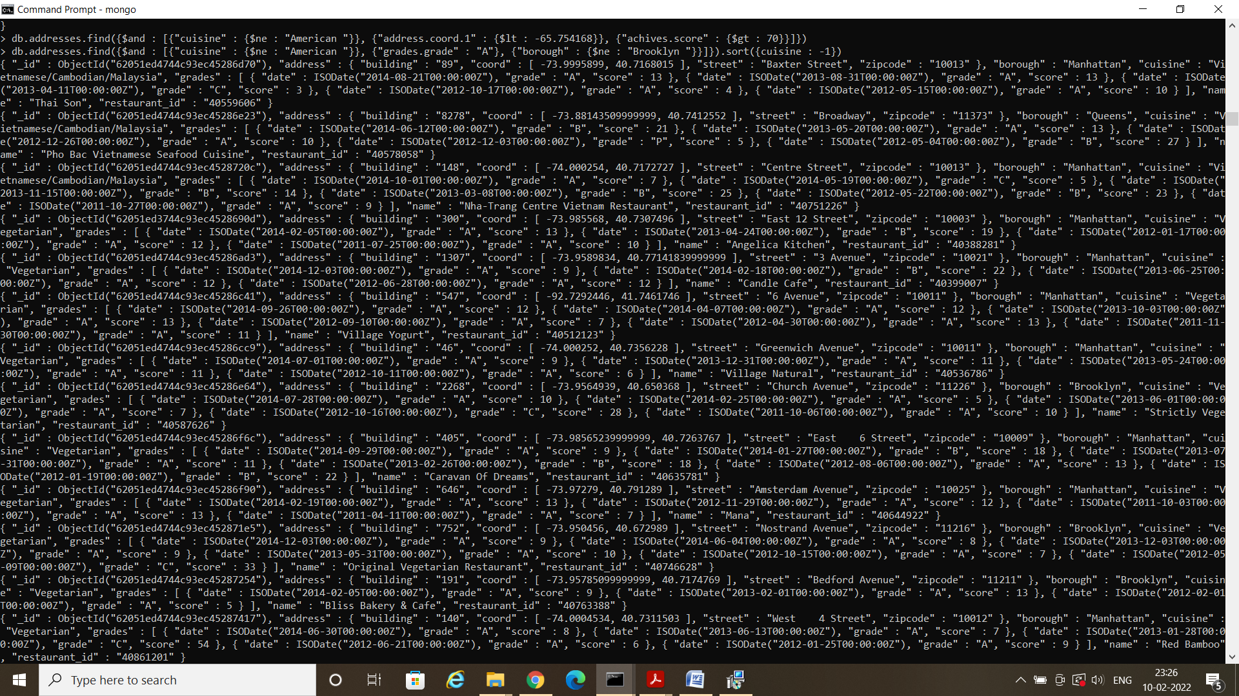

14. Write a MongoDB query to find the restaurant Id, name, borough and cuisine for those addresses which contain 'Wil' as first three letters for its name.

15. Write a MongoDB query to find the restaurant Id, name, borough and cuisine for those addresses which contain 'ces' as last three letters for its name.

16. Write a MongoDB query to find the restaurant Id, name, borough and cuisine for those addresses which contain 'Reg' as three letters somewhere in its name.

17. Write a MongoDB query to find the addresses which belong to the borough Bronx and prepared either American or Chinese dish.

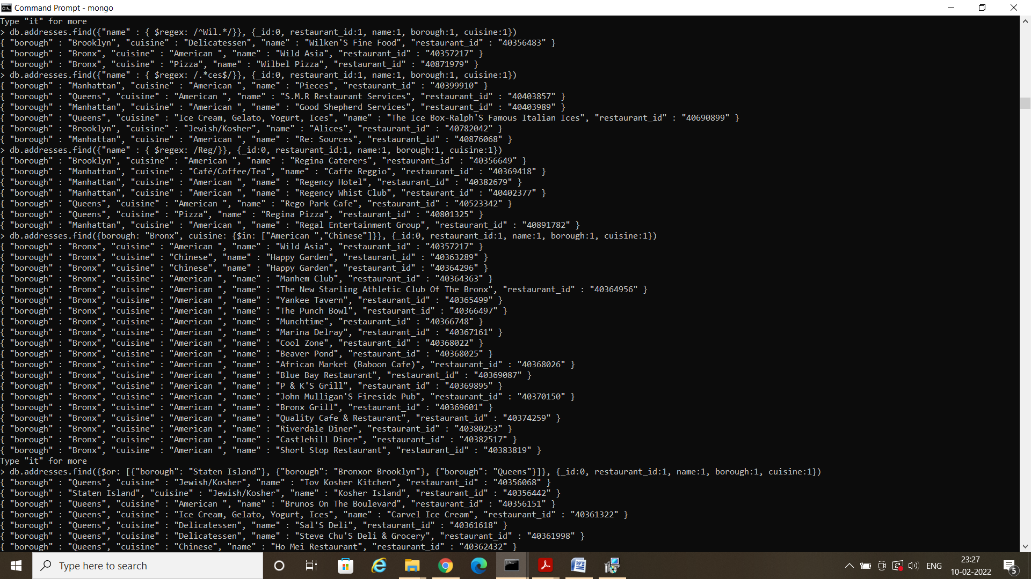

18. Write a MongoDB query to find the restaurant Id, name, borough and cuisine for those addresses which belong to the borough Staten Island or Queens or Bronxor Brooklyn.

19. Write a MongoDB query to find the restaurant Id, name, borough and cuisine for those addresses which are not belonging to the borough Staten Island or Queens or Bronxor Brooklyn.

20. Write a MongoDB query to find the restaurant Id, name, borough and cuisine for those addresses which achieved a score which is not more than 10.

21. Write a MongoDB query to find the restaurant Id, name, borough and cuisine for those addresses which prepared dish except 'American' and 'Chinees' or restaurant's name begins with letter 'Wil'.

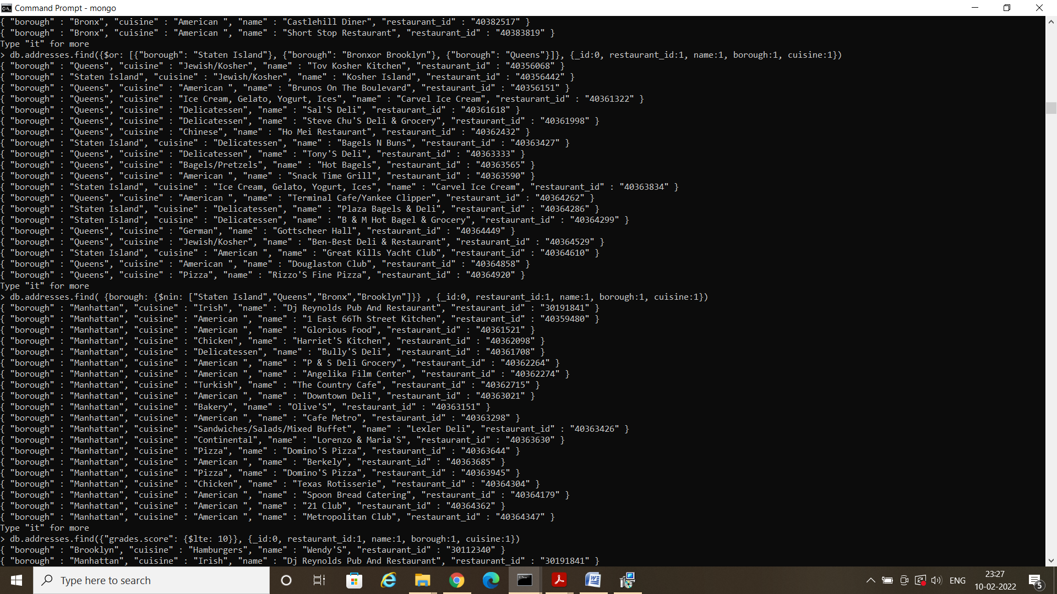

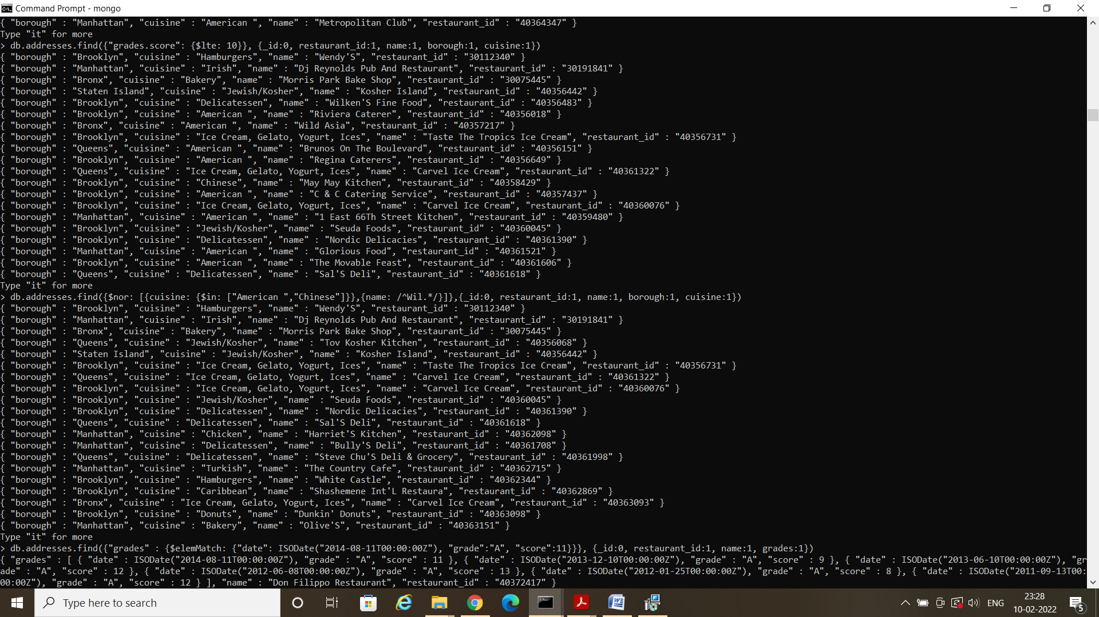

22. Write a MongoDB query to find the restaurant Id, name, and grades for those addresses which achieved a grade of "A" and scored 11 on an ISODate "2014-08-11T00:00:00Z" among many of survey dates..

23. Write a MongoDB query to find the restaurant Id, name and grades for those addresses where the 2nd element of grades array contains a grade of "A" and score 9 on an ISODate "2014-08-11T00:00:00Z"

24. Write a MongoDB query to find the restaurant Id, name, address and geographical location for those addresses where 2nd element of coord array contains a value which is more than 42 and upto 52..

25. Write a MongoDB query to arrange the name of the addresses in ascending order along with all the columns.

26. Write a MongoDB query to arrange the name of the addresses in descending along with all the columns.

27. Write a MongoDB query to arranged the name of the cuisine in ascending order and for that same cuisine borough should be in descending order.



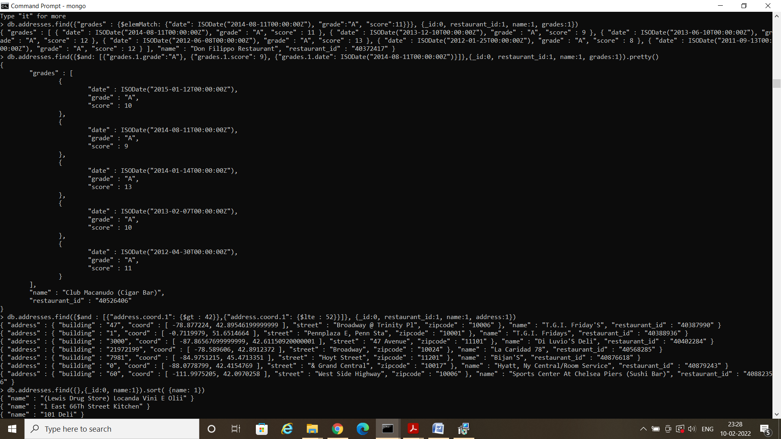

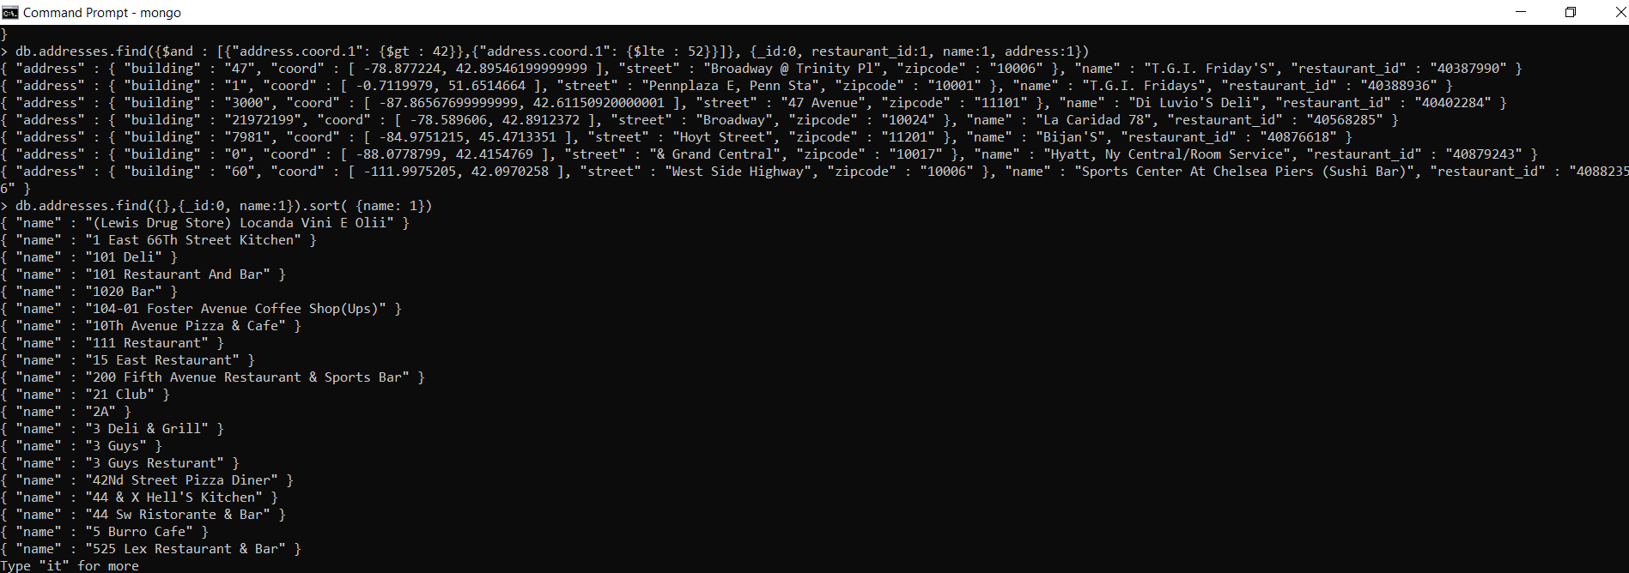

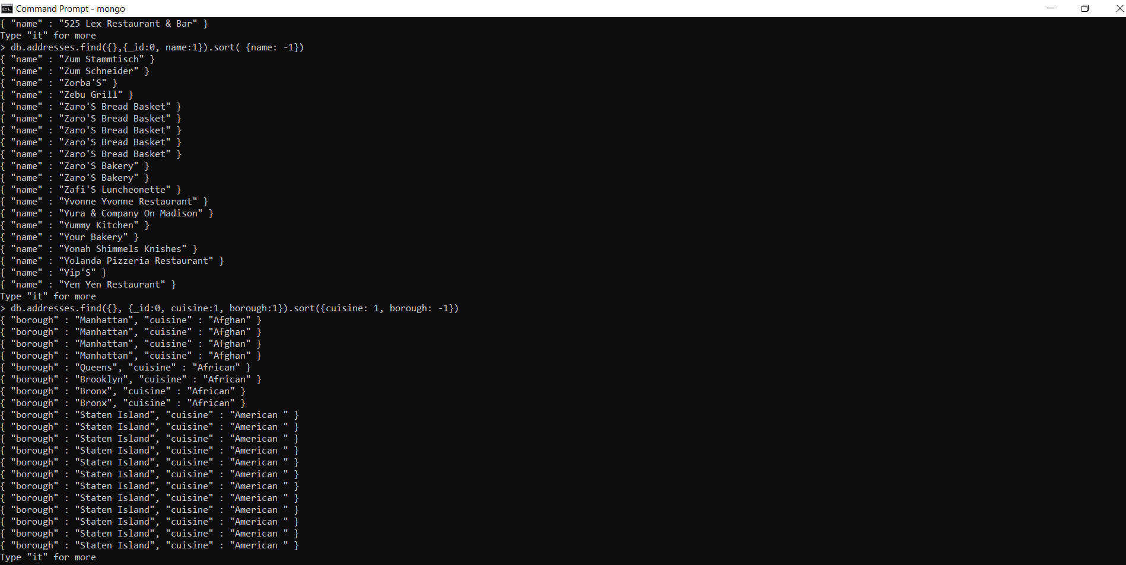

28. Write a MongoDB query to know whether all the contains the street or not.

29. Write a MongoDB query which will select all documents in the addresses collection where the coord field value is Double.

30. Write a MongoDB query which will select the restaurant Id, name and grades for those addresses which returns 0 as a remainder after dividing the score by 7.

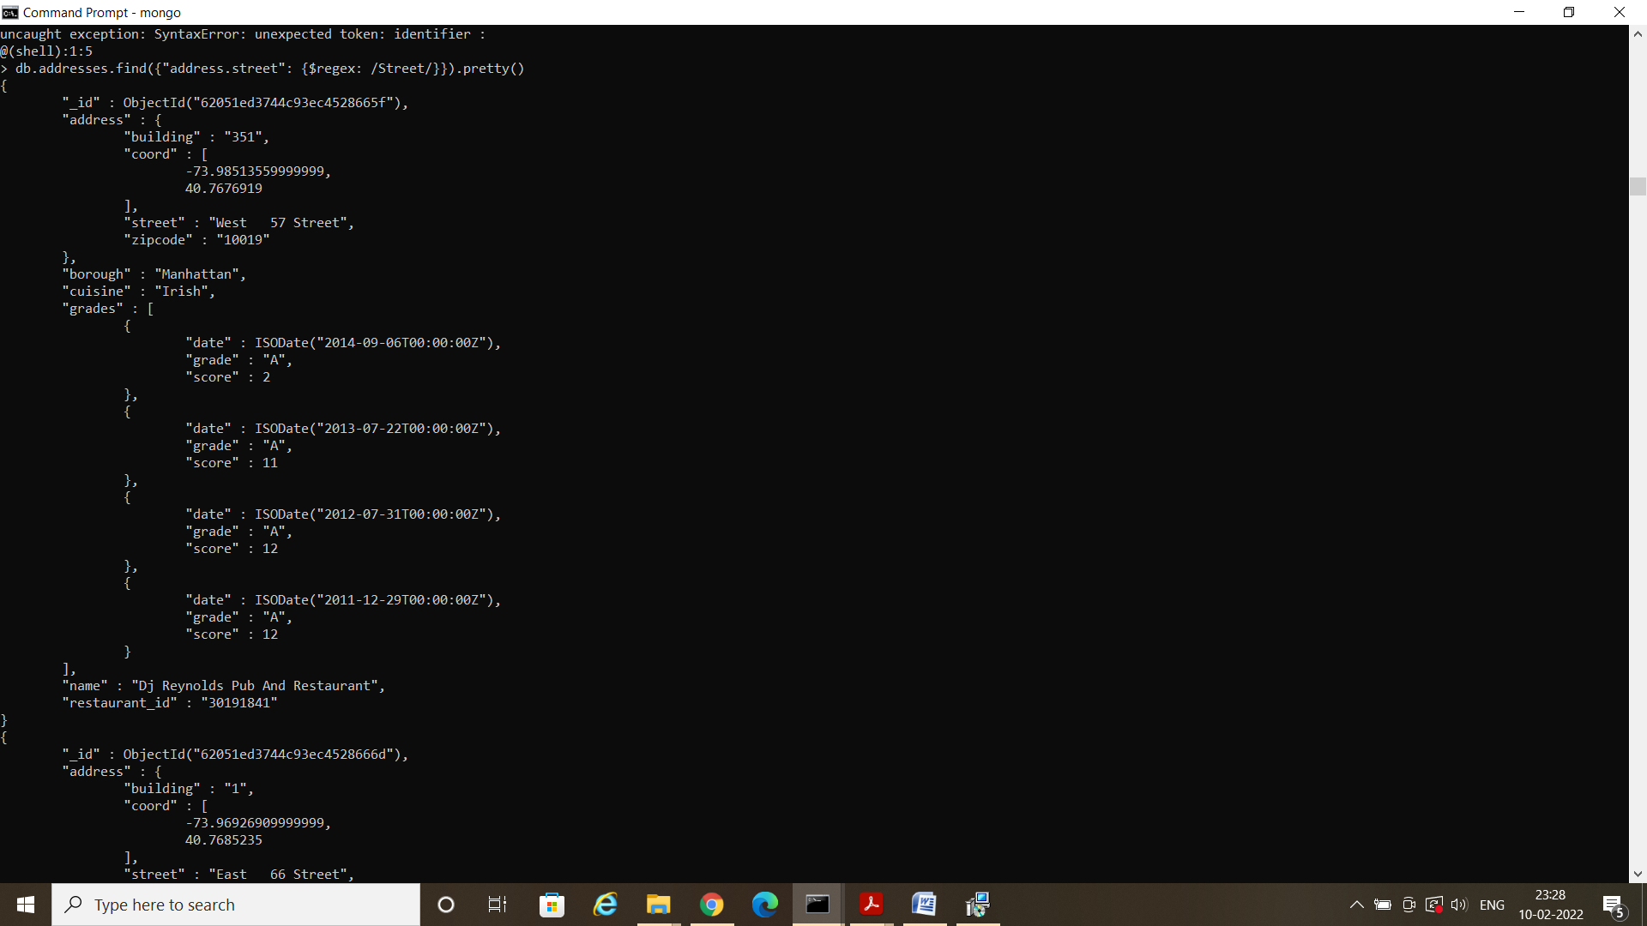

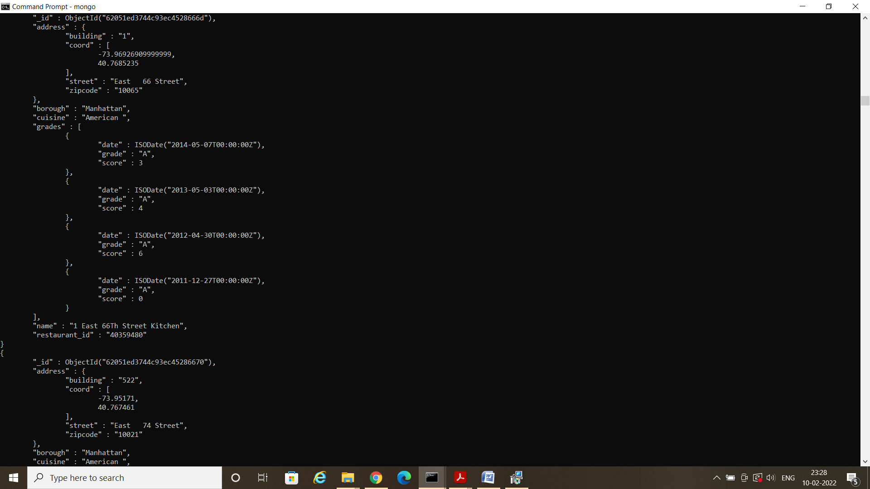

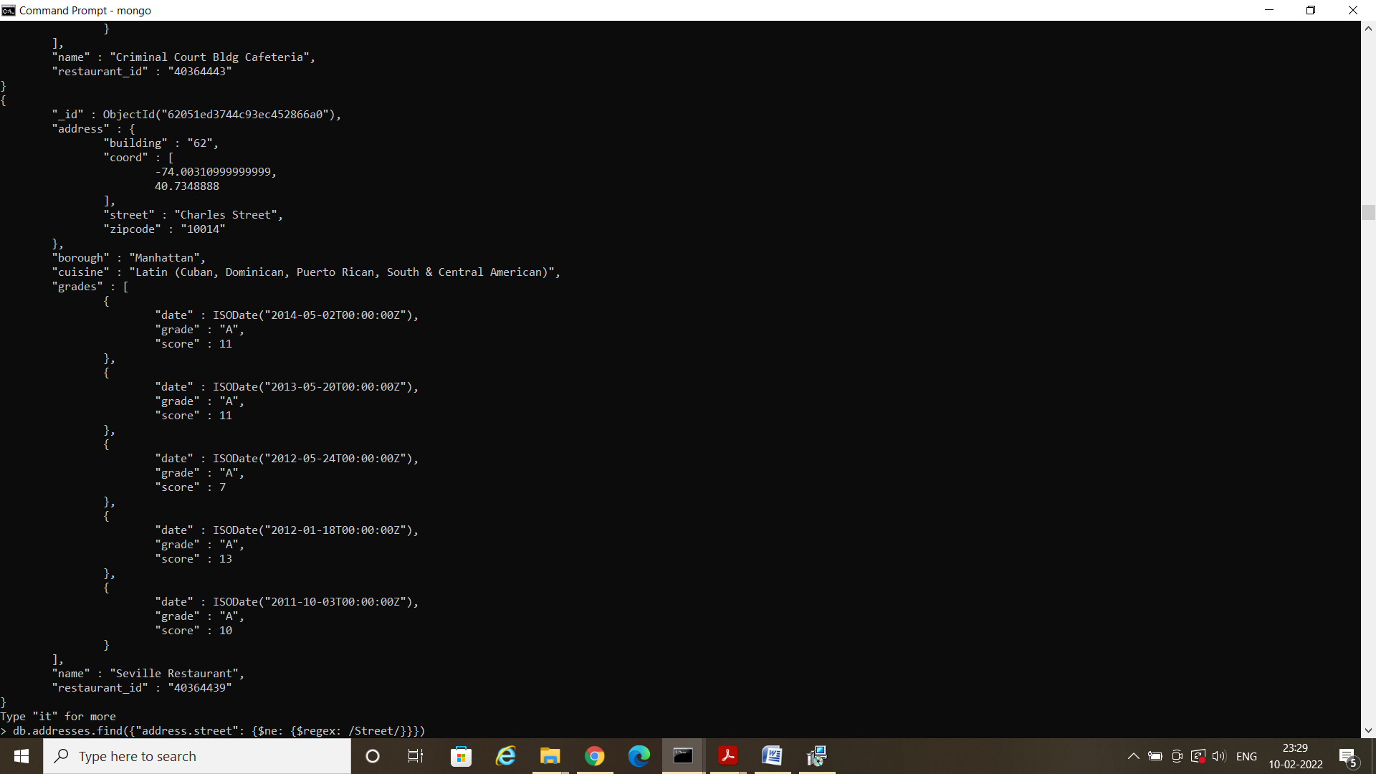

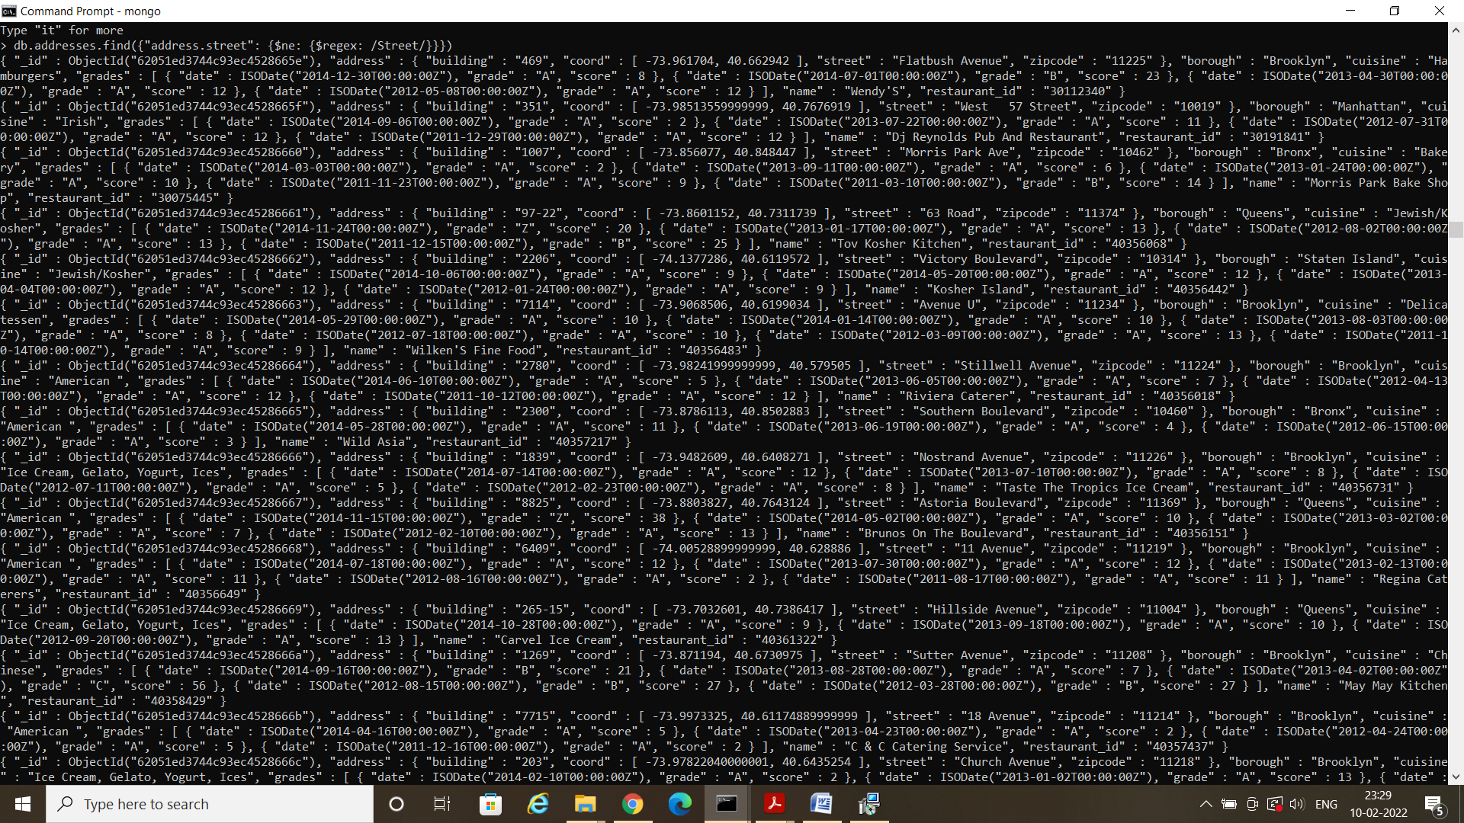

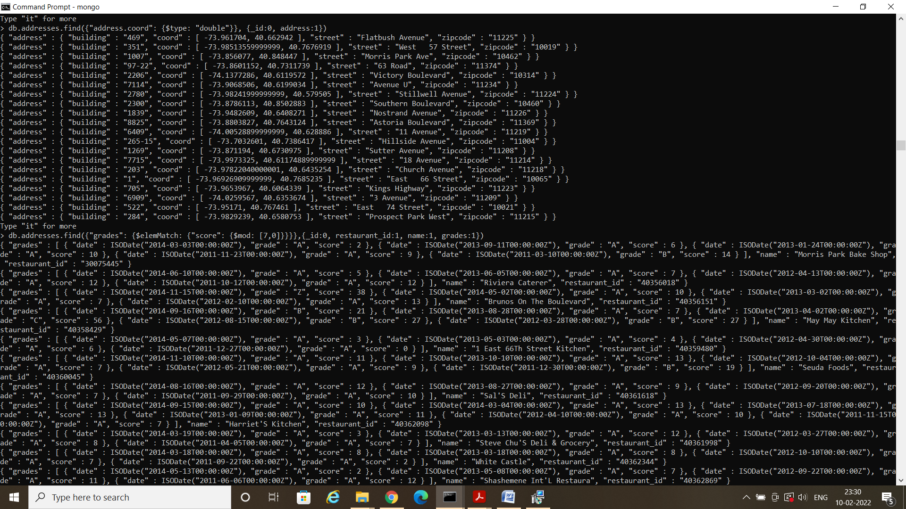

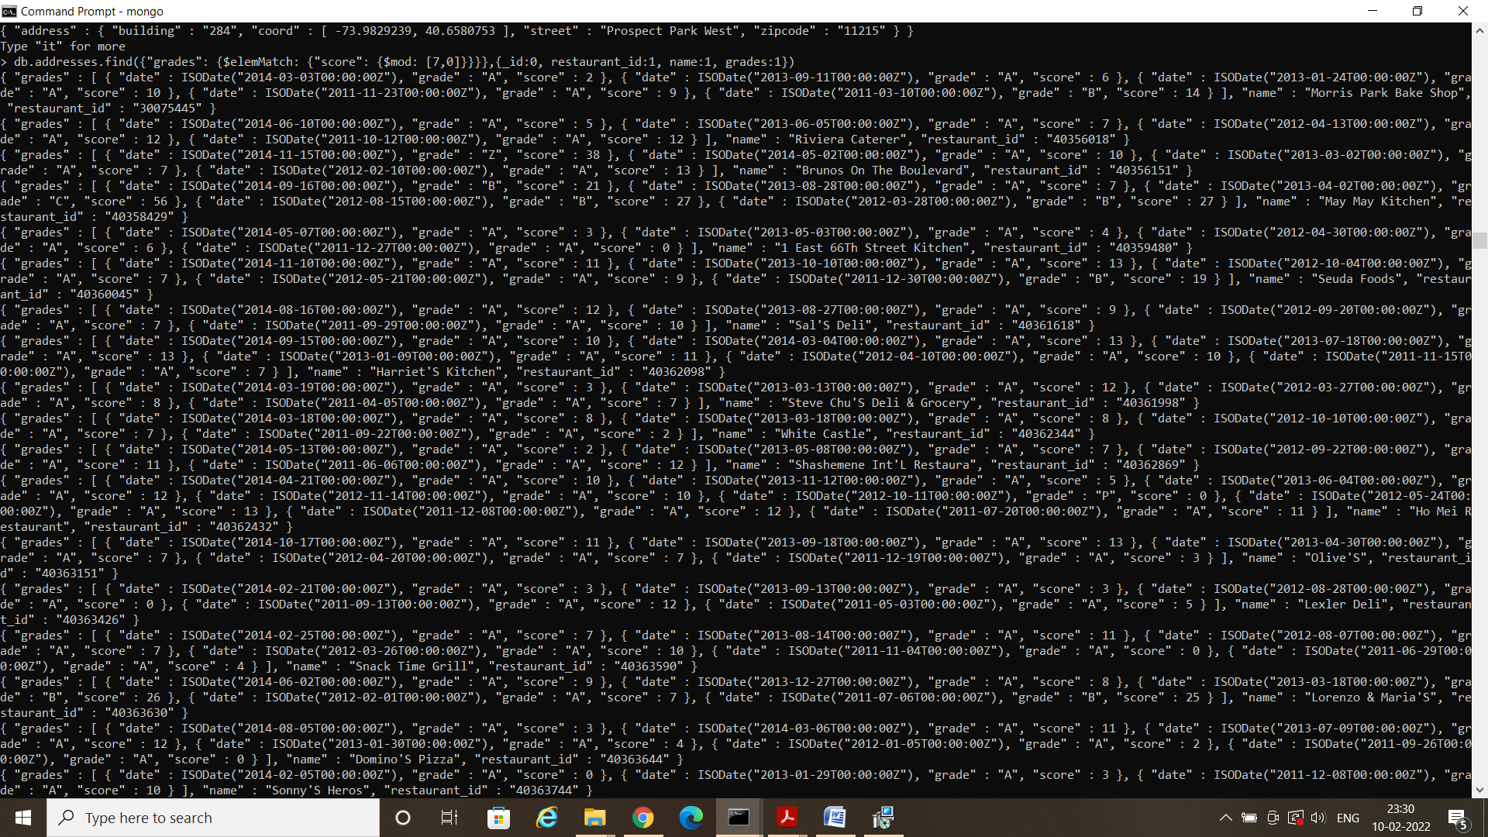

31. Write a MongoDB query to find the restaurant name, borough, longitude and attitude and cuisine for those addresses which contains 'mon' as three letters somewhere in its name.

32. Write a MongoDB query to find the restaurant name, borough, longitude and latitude and cuisine for those addresses which contain 'Mad' as first three letters of its name.

